Question 2 (6 marks)

The Cartesian equations for three planes are $x-y-z=2, 2x-y+z=7$ and $3x+y+z=2$.

(a) Show that none of these planes is parallel to another. (2 marks)

(b) Solve the three equations simultaneously. (3 marks)

(c) State the geometric interpretation of the solution obtained in part (b). (1 mark)

Question 2 (6 marks)

The Cartesian equations for three planes are $x-y-z=2, 2x-y+z=7$ and $3x+y+z=2$.

(a) Show that none of these planes is parallel to another. (2 marks)

|  |
| --- |
| Solution |
| The planes have normal vectors $\left(\begin{matrix}1 \\ -1 \\ -1\end{matrix}\right), \left(\begin{matrix}2 \\ -1 \\ 1\end{matrix}\right), \left(\begin{matrix}3 \\ 1 \\ 1\end{matrix}\right)$ and since none of these are scalar multiples of each other, then none of the three planes is parallel to one of the others. |
| Specific behaviours |
| ✓ correctly states all normal vectors  ü correct explanation |

(b) Solve the three equations simultaneously. (3 marks)

|  |
| --- |
| Solution |
| $$x-y-z=2 \\ 3x+y+z=2 \\ 4x=4, x=1$$ $$1-y-z=2 \\ 2-y+z=7 \\ 3-2y=9, y=-3$$ $$3-3+z=2, z=2$$ $$x=1, y=-3, z=2$$ |
| Specific behaviours |
| ✓ uses elimination to obtain value of $x$ ü uses elimination to obtain a second value  ü states correct solution set |

(c) State the geometric interpretation of the solution obtained in part (b). (1 mark)

|  |
| --- |
| Solution |
| Three non-parallel planes intersecting at the point $(1, -3, 2)$. |
| Specific behaviours |
| ✓ correctly interprets solution |

Question 4 (7 marks)

The coordinates of three points in space are $L\left(0, 3, 3\right), M(-2, 1, -1)$ and $N(-1, 1, 2)$.

(a) Determine the vector equation of the sphere with diameter $LM$. (3 marks)

(b) Determine the Cartesian equation of the plane that contains all three points. (4 marks)

Question 4 (7 marks)

The coordinates of three points in space are $L\left(0, 3, 3\right), M(-2, 1, -1)$ and $N(-1, 1, 2)$.

(a) Determine the vector equation of the sphere with diameter $LM$. (3 marks)

|  |
| --- |
| Solution |
| Centre: $$\frac{1}{2}\left(\left(\begin{matrix}0 \\ 3 \\ 3\end{matrix}\right)+\left(\begin{matrix}-2 \\ 1 \\ -1\end{matrix}\right)\right)=\left(\begin{matrix}-1 \\ 2 \\ 1\end{matrix}\right)$$ Radius:  Equation: |
| Specific behaviours |
| ✓ calculates centre  ü calculates radius or diameter  ü correct vector equation |

(b) Determine the Cartesian equation of the plane that contains all three points. (4 marks)

|  |
| --- |
| Solution |
| $$\vec{ML}=\left(\begin{matrix}0 \\ 3 \\ 3\end{matrix}\right)-\left(\begin{matrix}-2 \\ 1 \\ -1\end{matrix}\right)=\left(\begin{matrix}2 \\ 2 \\ 4\end{matrix}\right), \vec{NL}=\left(\begin{matrix}0 \\ 3 \\ 3\end{matrix}\right)-\left(\begin{matrix}-1 \\ 1 \\ 2\end{matrix}\right)=\left(\begin{matrix}1 \\ 2 \\ 1\end{matrix}\right)$$ Normal to plane: $$\underset{∼}{n}=\left(\begin{matrix}1 \\ 1 \\ 2\end{matrix}\right)×\left(\begin{matrix}1 \\ 2 \\ 1\end{matrix}\right)=\left(\begin{matrix}-3 \\ 1 \\ 1\end{matrix}\right)$$ Constant: $$\left(\begin{matrix}-3 \\ 1 \\ 1\end{matrix}\right)∙\left(\begin{matrix}0 \\ 3 \\ 3\end{matrix}\right)=6$$ Cartesian equation: $$-3x+y+z=6$$ |
| Specific behaviours |
| ✓ derives two vectors in the plane  ü calculates normal to plane  ü calculates constant  ü correct cartesian equation |

Question 4 (9 marks)

(a) Solve the following system of equations and interpret the solution geometrically.

(4 marks)

$$x+y+z=3 \\ 2x+y+3z=4 \\ x-y+z=-5$$

(b) The position vectors of points $A, B$ and $C$ are $\vec{OA}=\left(\begin{matrix}0 \\ -5 \\ 6\end{matrix}\right),\vec{OB}=\left(\begin{matrix}3 \\ -3 \\ 2\end{matrix}\right)$ and $\vec{OC}=\left(\begin{matrix}1 \\ 2 \\ -2\end{matrix}\right)$.  
  
Determine the Cartesian equation of the plane through the line $AB$ and perpendicular to the plane $OBC$. (5 marks)

Question 4 (9 marks)

(a) Solve the following system of equations and interpret the solution geometrically.

(4 marks)

$$x+y+z=3 \\ 2x+y+3z=4 \\ x-y+z=-5$$

|  |
| --- |
| Solution |
| $$R_{1}-R_{3}:2y=8→y=4$$ $$R_{2}-2R_{3}:3y+z=14→z=2$$ $$R_{1}:x+4+2=3→x=-3$$ Solution $x=-3, y=4, z=2$ represents the unique point at which the three planes meet. |
| Specific behaviours |
| ✓ correctly eliminates at least one variable  ü solves correctly for one variable  ü solves correctly for all variables  ü correctly interprets solution |

(b) The position vectors of points $A, B$ and $C$ are $\vec{OA}=\left(\begin{matrix}0 \\ -5 \\ 6\end{matrix}\right),\vec{OB}=\left(\begin{matrix}3 \\ -3 \\ 2\end{matrix}\right)$ and $\vec{OC}=\left(\begin{matrix}1 \\ 2 \\ -2\end{matrix}\right)$.  
  
Determine the Cartesian equation of the plane through the line $AB$ and perpendicular to the plane $OBC$. (5 marks)

|  |
| --- |
| Solution |
| Vector perpendicular to plane $OBC$ is $$\vec{OB}×\vec{OC}=\left(\begin{matrix}3 \\ -3 \\ 2\end{matrix}\right)×\left(\begin{matrix}1 \\ 2 \\ -2\end{matrix}\right)=\left(\begin{matrix}2 \\ 8 \\ 9\end{matrix}\right)$$ $$\vec{AB}=\vec{OB}-\vec{OA}=\left(\begin{matrix}3 \\ -3 \\ 2\end{matrix}\right)-\left(\begin{matrix}0 \\ -5 \\ 6\end{matrix}\right)=\left(\begin{matrix}3 \\ 2 \\ -4\end{matrix}\right)$$ Hence normal to required plane: $\left(\begin{matrix}3 \\ 2 \\ -4\end{matrix}\right)×\left(\begin{matrix}2 \\ 8 \\ 9\end{matrix}\right)=\left(\begin{matrix}50 \\ -35 \\ 20\end{matrix}\right)=5\left(\begin{matrix}10 \\ -7 \\ 4\end{matrix}\right)$ Using point $A$: $\left(\begin{matrix}10 \\ -7 \\ 4\end{matrix}\right)∙\left(\begin{matrix}0 \\ -5 \\ 6\end{matrix}\right)=59$ Hence Cartesian equation is $10x-7y+4z=59$. |
| Specific behaviours |
| ✓ normal vector to plane $OBC$ ü vector $\vec{AB}$ ü normal to required plane  ü evaluates constant  ü writes Cartesian equation |

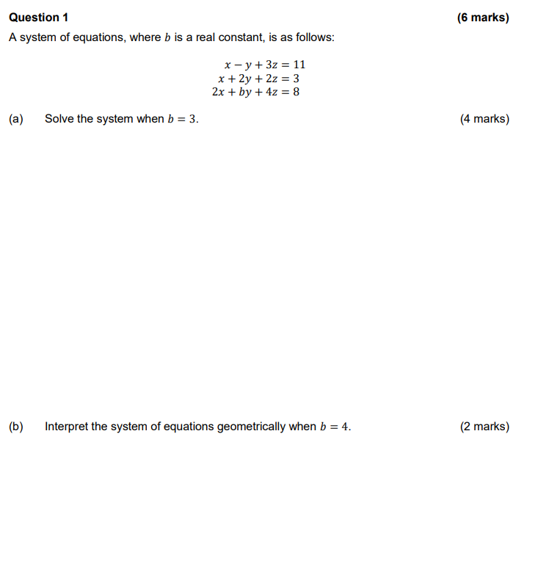

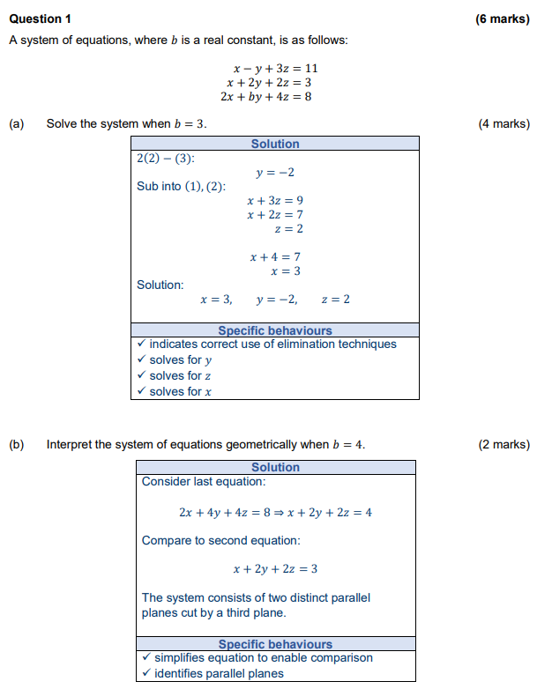

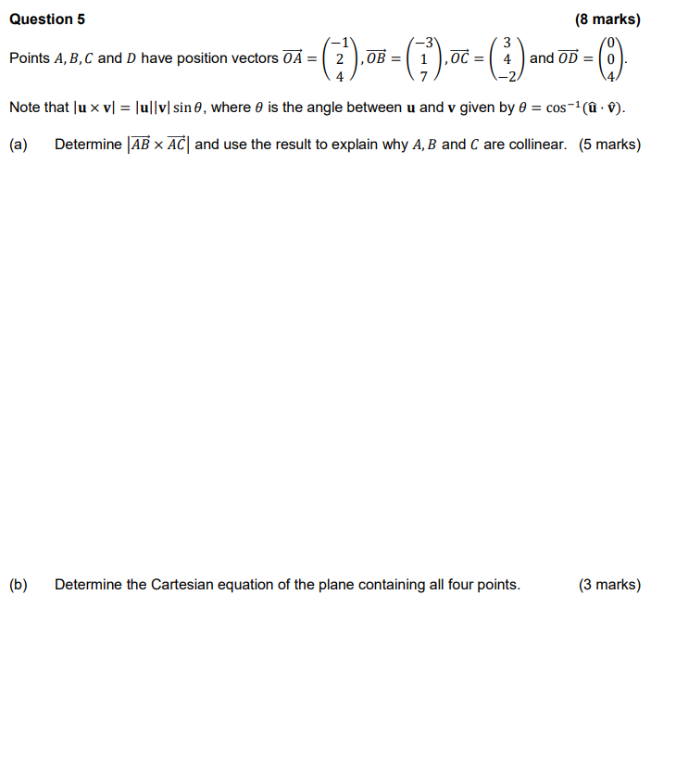

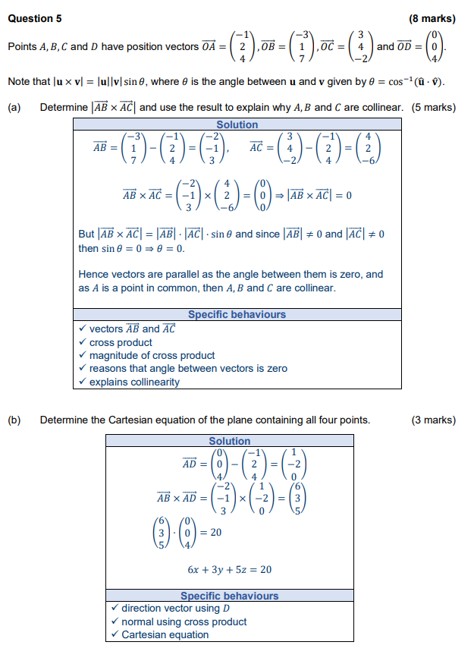

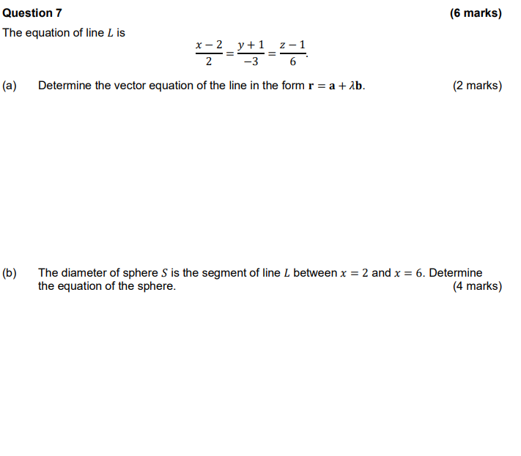

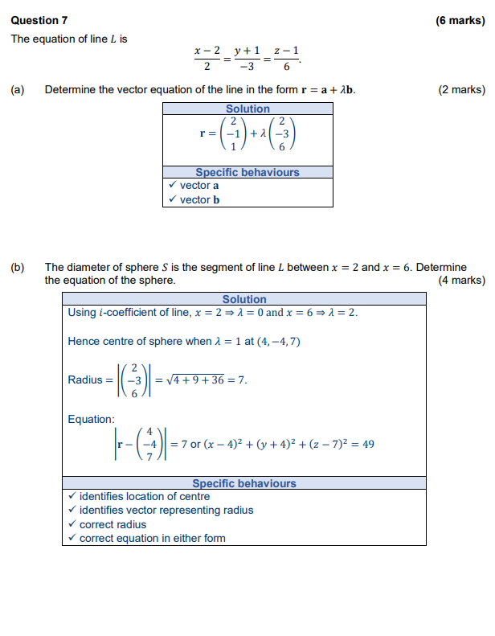

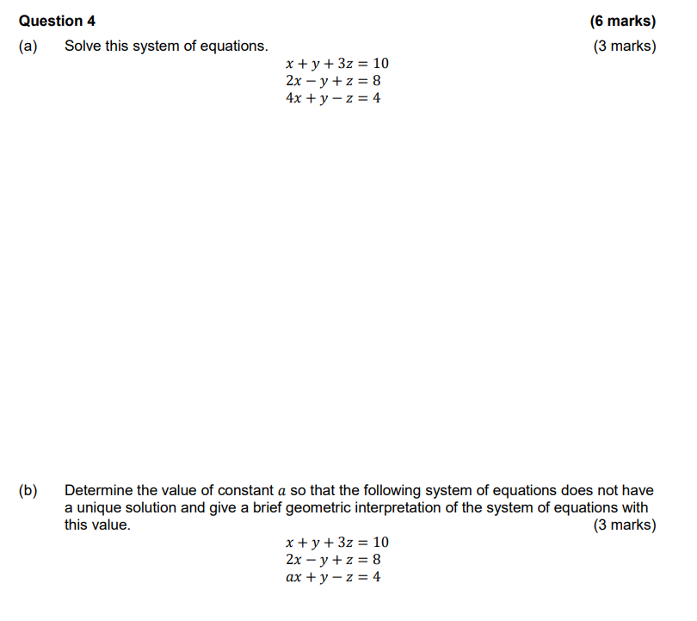

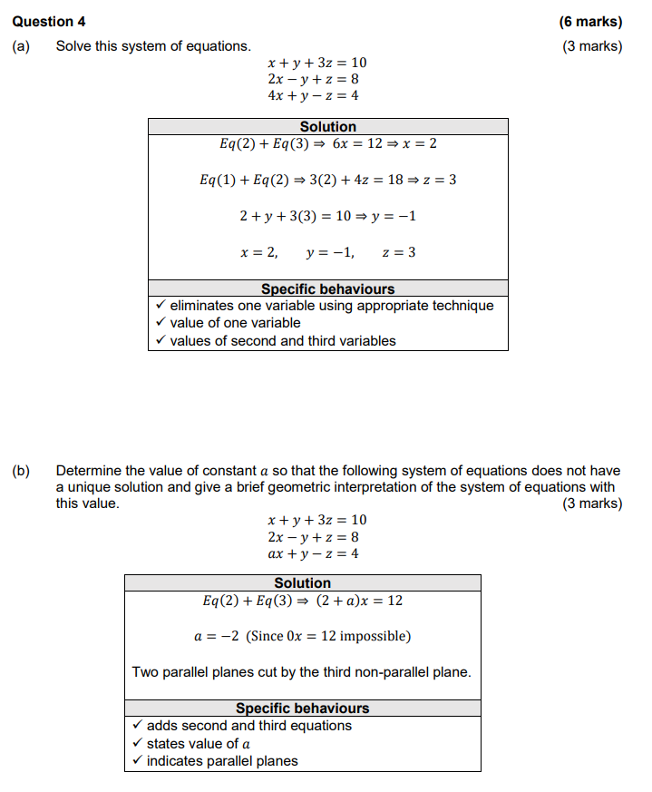

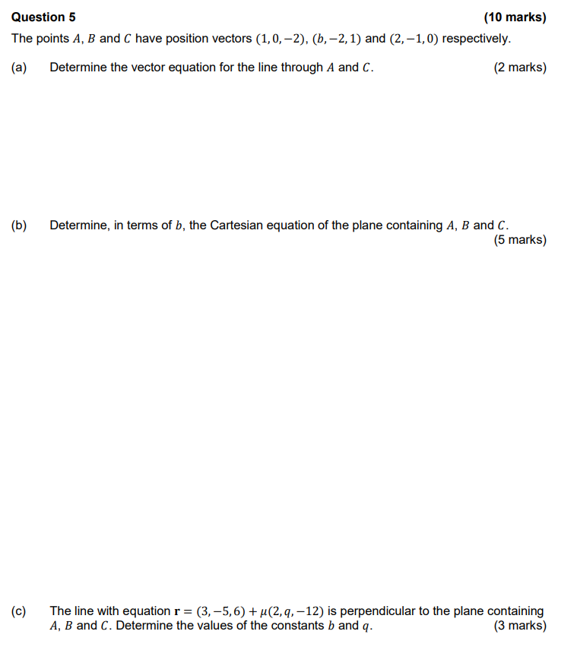

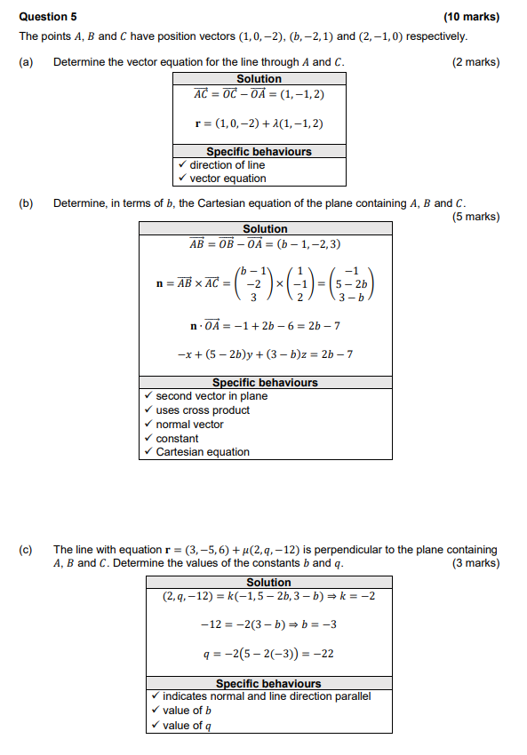

Question 2 (7 marks)

A sphere has equation .

(a) Determine the coordinates of the centre and the radius of the sphere. (4 marks)

(b) Determine the vector equation of the straight line that passes through the points on the sphere where  and . (3 marks)

Question 2 (7 marks)

A sphere has equation .

(a) Determine the coordinates of the centre and the radius of the sphere. (4 marks)

|  |
| --- |
| **Solution** |
|  |
| **Specific behaviours** |
| ✓ divides both sides by 2  ✓ completes the squares  ✓ states the radius  ✓ states centre |

(b) Determine the vector equation of the straight line that passes through the points on the sphere where  and . (3 marks)

|  |
| --- |
| **Solution** |
|  |
| **Specific behaviours** |
| ✓ determines x-coordinates of points on sphere  ✓ states direction of line  ✓ states vector equation of line |

Question 4 (7 marks)

Consider the following system of equations, where k is a real constant.



(a) Solve the system of equations when . (3 marks)

(b) Show that no value of k exists for the system of equations to represent three planes intersecting in a single straight line. (4 marks)

Question 4 (7 marks)

Consider the following system of equations, where k is a real constant.



(a) Solve the system of equations when . (3 marks)

|  |
| --- |
| **Solution** |
|  |
| **Specific behaviours** |
| ✓ eliminates x and z to find y  ✓ eliminates and solves for another variable  ✓ states values of all three variables |

(b) Show that no value of k exists for the system of equations to represent three planes intersecting in a single straight line. (4 marks)

|  |
| --- |
| **Solution** |
|  |
| **Specific behaviours** |
| ✓ reduces second and third rows in initial matrix  ✓ reduces third row in second matrix  ✓ indicates condition for planes to intersect in single straight line  ✓ shows that no value of k exists |

Question 5 (8 marks)

(a) Determine the vector equation of the plane that contains the points A(1, -1, 2), B(2, 1, 0) and C(3, -1, 1). (4 marks)

(b) Plane  has equation . Line L is perpendicular to and passes through the point (1, -6, 4). Determine where line L intersects plane . (4 marks)

Question 5 (8 marks)

(a) Determine the vector equation of the plane that contains the points A(1, -1, 2), B(2, 1, 0) and C(3, -1, 1). (4 marks)

|  |
| --- |
| **Solution** |
|  |
| **Specific behaviours** |
| ✓ finds two vectors in plane  ✓ calculates cross product of two vectors  ✓ substitutes into vector equation of plane  ✓ simplifies vector equation |

(b) Plane  has equation . Line L is perpendicular to and passes through the point (1, -6, 4). Determine where line L intersects plane . (4 marks)

|  |
| --- |
| **Solution** |
|  |
| **Specific behaviours** |
| ✓ writes vector equation of plane  ✓ writes vector equation of line through point  ✓ substitutes line into plane and solves for t  ✓ determines coordinates of point |

Question 7 (10 marks)

Particle A has position vector given by , where t is the time in seconds.

(a) Show that the path of the particle is circular. (2 marks)

Particle B is stationary, with position vector .

(b) Determine an expression for the distance between particles A and B in terms of t.

(2 marks)

(c) Determine the position vector of the A when it is (i) nearest and (ii) furthest from B.

(6 marks)

Question 7 (10 marks)

Particle A has position vector given by , where t is the time in seconds.

(a) Show that the path of the particle is circular. (2 marks)

|  |
| --- |
| **Solution** |
|  |
| **Specific behaviours** |
| ✓ converts to Cartesian form  ✓ states centre and radius |

Particle B is stationary, with position vector .

(b) Determine an expression for the distance between particles A and B in terms of t.

(2 marks)

|  |
| --- |
| **Solution** |
|  |
| **Specific behaviours** |
| ✓ determines vector **BA** (or **AB**)  ✓ states magnitude of vector |

(c) Determine the position vector of the A when it is (i) nearest and (ii) furthest from B.

(6 marks)

|  |
| --- |
| **Solution** |
| Let S be square of distance between particles: |
| **Specific behaviours** |
| ✓ differentiates S  ✓ simplifies and equates derivative to 0  ✓ determines solution for tan t  ✓ derives possible values for sin t and cos t  ✓ determines nearest position  ✓ determines furthest position |